ASSIGNMENT NO 8

Nirbhay Ahir

[Nirbhay.ahir36@gmail.com](mailto:Nirbhay.ahir36@gmail.com)

1. Is the Python Standard Library included with PyInputPlus?

Ans: The PyInputPlus is not included with pythons standard library. Tp use it we have to install it with the help of pip command.

2. Why is PyInputPlus commonly imported with import pyinputplus as pypi?

Ans: For the pyinputplus , pypi is the allias name so that whenever we want to use the module we can call it by a shorter name pypi which is same as PyInputPlus.

3. How do you distinguish between inputInt() and inputFloat()?

Ans: inpuInt() accepts a integer value and always returns a integer value.

inputFloat() accepts a floating point/integer value and always return a floating point value.

4. Using PyInputPlus, how do you ensure that the user enters a whole number between 0 and 99?

Ans: We can ensure it by specifying the minimum and the maximum value while asking for input.

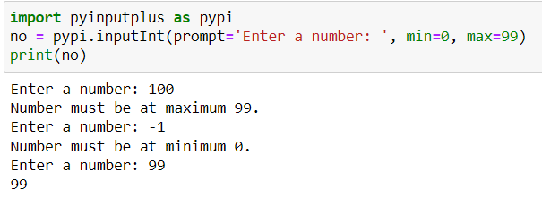

5. What is transferred to the keyword arguments allowRegexes and blockRegexes?

Ans: we can use allowRegexes and blockRegexes keyword arguments to take list of regular expression strings to determine what the pyinputplus function will reject or accept valid input.

6. If a blank input is entered three times, what does inputStr(limit=3) do?

Ans: After a blank input is entered three times, it will throw a RetryLimitException as maximum trials were only 3.

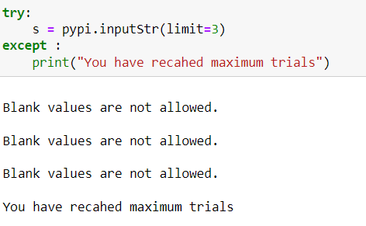

7. If blank input is entered three times, what does inputStr(limit=3, default='hello') do?

Ans: After a blank input is entered three times, it will return “hello” as response and it will not raise RetryLimitException.

